**REVOLUTIONIZING TUMOR DIAGNOSIS WITH AI: AI INDEPT****H ANALYSIS OF IMAGE DATASETS**

**A MINOR PROJECT REPORT**

***Submitted by***

**YESHWANTH J(RA2111003040076)** **WILFRED AUXILIAN G(RA2111003040077)**

**C ABISHEK(RA2111003040109)**

*Under the guidance of*

**Mrs. R. DEEPA**

(ASSISTANT PROFESSOR,DEPARTMENT OF CSE/CSE(ETECH))

***in partial fulfillment for the award of the degree of***

**BACHELOR OF TECHNOLOGY**

in

**COMPUTER SCIENCE & ENGINEERING**

of

**FACULTY OF ENGINEERING AND TECHNOLOGY**



**SRM INSTITUTE OF SCIENCE AND TECHNOLOGY VADAPALANI CAMPUS**

**OCTOBER 2024**



**BONAFIDE CERTIFICATE**

Certified that this project report titled “**REVOLUTIONIZING TUMOR DIAGNOSIS WITH AI: AI INDEPTH ANALYSIS OF IMAGE DATASETS**”is the bonafide work of “**YESHWANTH J(RA2111003040076),WILFRED AUXILIAN**

**G(RA2111003040077),CABISHEK(RA2111003040109)**”,who carried out the minor project work under my supervision. Certified further, that to the best of my knowledge the work reported herein does not form any other project report or dissertation on the basis of which a degree or award was conferred on an earlier occasion on this or any other candidate.

**SIGNATURE SIGNATURE**

Mrs. R .DEEPA Dr.S.PRASANNA DEVI

**GUIDE HEAD OF THE DEPARTMENT**

Assistant Professor Professor

Dept. of CSE / CSE (ETech) Dept. of CSE / CSE(ETech)

Signature of the Internal Examiner

|  |  |  |
| --- | --- | --- |
| S.NO | TOPICS | PAGE NO |
| 1 | ABSTRACT | 4 |
| 2 | INTRODUCTION | 5 |
| 3 | LITERATURE REVIEW | 6 |
| 4 | EXISTING SYSTEM | 7 |
| 5 | PROPOSED SYSTEM  5.1 Special Features  5.2 Expected Results | 8 - 9 |
| 6 | METHODOLOGY  6.1 Data Collection and Priorities  6.2 Positive Progress  6.3 Sample Analysis  6.4 Best Usement | 10 - 11 |
| 7 | PROCEDURE  7.1 Import Libraries  7.2 Create an Information Set  7.3 DataBlock Creation  7.4 Data Enhancement Progress  7.5 Model Construction and Training  7.6 Sample Analysis  7.7 Sample Storage  7.8 Account and User Interface | 12 - 14 |
| 8 | RESULTS | 15 - 22 |
| 9 | CONCLUSION | 23 |
| 10 | ACKNOWLEDGEMENTS | 24 |
| 11 | REFERENCES | 25 |

# **ABSTRACT**

Cancer is one of the leading causes of human morbidity and mortality worldwide and we want to find new ways to detect it.AI is changing how we do clinical diagnosis of tumors. In this paper, when A.I. The study shows how important it is to use deep learning models like CNN to look at tons of image data. Using clever techniques including record enhancement, switch detection and model tweaking, this study seeks to improve the accuracy and speed of analysis It also looks at issues related to the use of AI in hospitals, a knowledge of how AI makes choices is included and It also ensures a good match between data and how doctors have already created the model. It would discuss the importance of accurate diagnosis, the methodology of using AI algorithms to interpret MRI images, results of tumor detection and classification, and potential implications for improving patient outcomes.

Keywords:-AI in clinical diagnosis, Deep learning models, MRI image analysis,cancer detection.

# **INTRODUCTION**

AI's entry into scientific diagnostics has a massive effect on with regards to finding and treating tumors. The antique ways of diagnosing frequently depend upon what doctors know, that may lead to errors with problematic cases like mind tumors. It's important to spot tumors and, as finding them can make a big difference in how doctors treat patients and how long they live. This paper looks at how deep AI learning helps make sense of medical images focusing on brain MRI scans. By using convolutional neural networks (CNN's), scientists can now go through huge amounts of data faster than ever. This does not make tumor detection more accurate but also gives radiologists less work, so they can spend time on the harder cases that need a human touch. The intro sets up a deep dive into the methods and tech behind AI-powered tumor diagnostics showing how they could change cancer care in a big way.

# **LITERATURE REVIEW**

Research on the use of AI for tumor diagnosis has grown exponentially over the past 10 years. This means more and more people are realizing how it can improve patient care. Several studies prove the effectiveness of deep learning methods CNNs for analyzing medical images. For example, work by Esteva and others showed in 2017 that CNN could sort skin cancer images as well as dermatologists.Studies on brain tumor detection also gave excellent results. The specimens are excellent at detecting tumors on MRI scans, rarely missing or misplaced. What’s more, research suggests different ways to improve model performance. These include methods for extending training datasets and transferring learning. This allows models trained on big data to be adapted for specific tasks. However, obstacles remain. We need highly labeled data sets and AI models that we can understand. Many professionals emphasize the need to combine AI solutions into modern scientific practice. This guarantees that conventional diagnostic techniques are supported and now not hindered. This evaluation of research demonstrates the ability of AI to revolutionize tumor diagnosis. It also identifies obstacles that want to be conquered for tremendous clinical utility.

# **EXISTING SYSTEM**

Before the integration of artificial intelligence (AI) into tumor prediction, traditional diagnostic systems relied heavily on human data and manual analysis of clinical images was time-consuming and potentially generous humans have made mistakes, especially in cases where tumors exhibit non-specific characteristics or are located in solid areas of the body.The current prominent tool is the conventional radiological approach, which uses multiple imaging modalities including MRI, CT scan and PET scan to detect tumors These systems commonly contain a multi-step process: acquiring pictures, pre-processing them for clarity, and then reading them for signs of malignancy. Relying on interpretive focus can lead to variability in assessment accuracy, with factors including fatigue, interest, and personal judgment affecting results - Emphasizes importance emphasizing that it enhances the beauty of accurate and efficient research.

# **PROPOSED SYSTEM**

The proposed machine the usage of AI pursuits to revolutionize tumor analysis by the use of advanced deep learning techniques to analyze medical image statistics, specially convolutional neural networks (CNNs) This gadget is designed to deal with the restrictions of traditional diagnostic methods by using supplying efficient, correct and scalable answer for tumor detection.

# **Special Features:**

* Automated photo evaluation: The AI gadget will routinely analyze MRI pix and pick out ability tumors with high sensitivity and specificity. These devices reduce the risk of human error and shorten the time to diagnosis.
* Integration with current workflows: The proposed devices are configured for seamless integration with modern clinical workflows allowing radiologists to promote AI-driven research without hiring are not involved in regulatory changes to ensure that AI acts as a complementary device as opposed to a replacement.
* Be constantly conscious: By adding a gadget to accumulate knowledge of tactics the machine can continuously Improve its Effectiveness via beginning new statistics. these variables are difficult for spare truth of the rating across time.
* easy-to-use Connection: associate in nursing smooth-to-use port leave bid radiologists with associate in nursing visceral port lease them survey findings exclusive the artificial intelligence and get fit choices founded along complete rating of an inch complete instances.

## **Expected Results:**

Improved characteristic Precision: leverage the electrical energy of artificial intelligence the planned unit is due to gain the truth of forecast ensuing inch associate in nursing already costly personal neoplasm psychoanalysis and advance personal effects.

# **METHODLOGY**

## **Data Collection and Priorities:**

* Data assets: Collection of clinical pics (MRI, CT, and PET scans) from hospitals and studies institutes.
* Data preprocessing: Preprocessor pictures the use of strategies such as normalization, facts enhancement, and noise reduction.

## **Positive Progress:**

* Deep learning algorithms: Use deep learning algorithms (e.g., TensorFlow, PyTorch) to generate a customized CNN model for tumor detection.
* Model Architecture: Create a CNN architecture that can efficiently learn features from medical images, such as convolutional layers, pooling layers, and fully connected layers.
* Model training: Train a CNN model using a preprocessed data set, with appropriate loss functions (e.g., cross-entropy) and optimization algorithms (e.g., ADAM).

## **Sample Analysis:-**

* Evaluation criteria: Use metrics such as accuracy, precision, recall, F1 scores, and receiver operating characteristic (ROC) curves to evaluate the performance of CNN models.
* Cross-validation: Perform k-fold cross-validation to check the model’s ability to generalize to unseen data.

## **Best Usement:-**

* Example of integration: Combine the educated CNN Edition into the proposed AI-Sended product and make sure compatibility with modern imaging structures and EHRs.
* Layout retention: Regularly update fashion with fashion based totally on new records and claims to reap normal Effectiveness and Adjust to converting medical desires. This is the notable split of options, and the real route also may be primarily based on the precise desires and dreams of the proposed AI- powered tool.

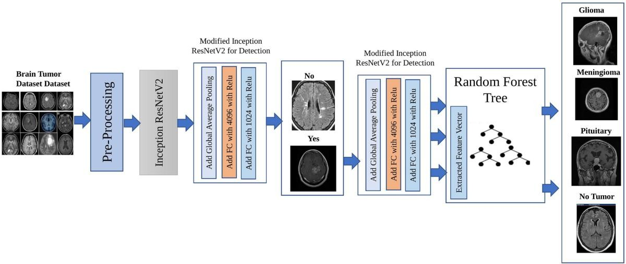.

# **PROCEDURE**

## **Import Libraries:-**

With Fast ai, the code begins via uploading the important libraries to set up a gadget getting to know environment. An incredible library built on pinnacle of PyTorch that simplifies the education of neurons.

## **Create An Information Set:-**

* Path definition: The code specifies the listing of the facts set. It is important to make sure that the path is accurate so that the version can access the snap shots.
* Types: Two classes are described for the type of venture: ‘no’ (indicating no tumor) and ‘yes’ (indicating tumor). This binary segmentation problem is common in medical imaging.

## **Data Block Creation:-**

* Blocks: The code specifies that the data consists of images (Image Block) and their corresponding categories (Category Block).
* Obtaining Resources: The function get_image_files is used to retrieve an image document from the desired path.
* Splitter: The RandomSplitter feature is used to randomly break up the data set into training and validation units, wherein 20% of the records is saved for validation. This allows the overall performance of the model to be checked on unseen data.

## **Data Enhancement Progress:-**

* Squish Method: The code resizes the photos with the use of the "Squish" approach, which changes the decision at the same time as keeping the factor ratio the sameThis facilitates keeping the photographs constant.
* Random Resized Crop: The code makes use of random cropping, permitting the version to examine from different parts of the picture. This approach enables us to prevent overfitting through introducing changes to the schooling information.

## **Model Construction and Schooling:-**

* CNN Learner: Convolutional neural network learner is constructed using ResNet architecture (first ResNet18, then ResNet34). ResNet algorithms are known to carry out properly in photo classification obligations because of the residual connectivity.
* Fine-tuning: The model is being fine-tuned in multiple stages (in this case 5). Micro-tuning is a method of continuously training a previously trained model on new data, allowing the model to adapt to the specific characteristics of the new data

## **Sample Analysis:-**

Confusion matrix: Once trained, the code generates a confusion matrix to visualize the performance of the model. The uncertainty matrix shows true positives, false positives, true negatives, and false negatives, and allows a detailed analysis of the predictions in the model

## **Sample Storage:-**

The trained model is exported and stored as a Pk report. This permits for destiny programs without having to retrain the version, making it less difficult to apply.

## **Account and User Interface:-**

* Loading models: The saved version is loaded for calculations on a brand-new version. The load_learner feature is used to load the version from a saved file.
* Forecast: The code consists of functionality on the way to allow users to upload pix and receive forecasts. It uses an easy interface with buttons for hovering and grouping photographs.

# **RESULTS**

## **Importing Data:-**

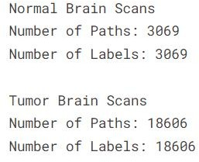

* 1. **Tumor Labels:-**



## **Class Types:-**



* 1. **Mapping Dictionary And Apply Mapping To Both Data-Frames:-**

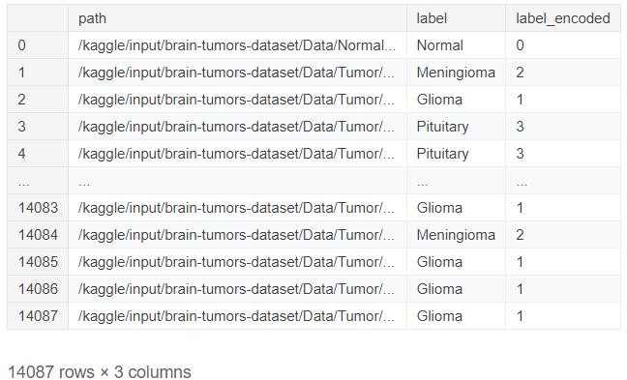

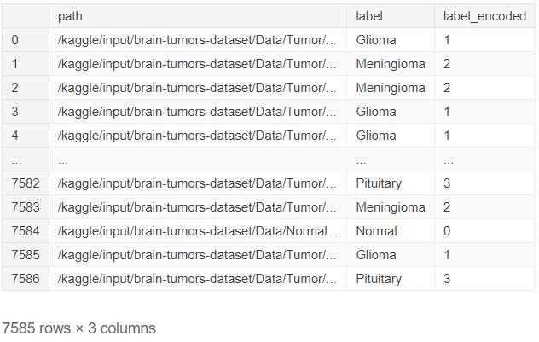

## **Training Data and Testing Data:-**

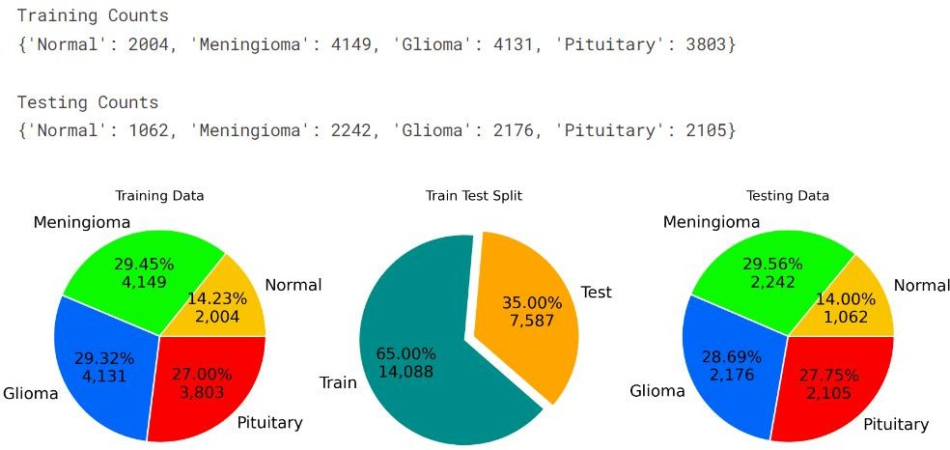

* 1. **Data Visualization:-**

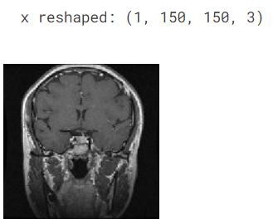

## **Four Different Data Classifying Images:-**

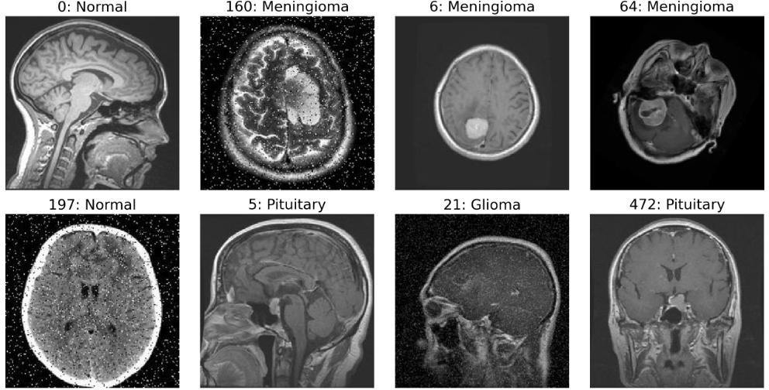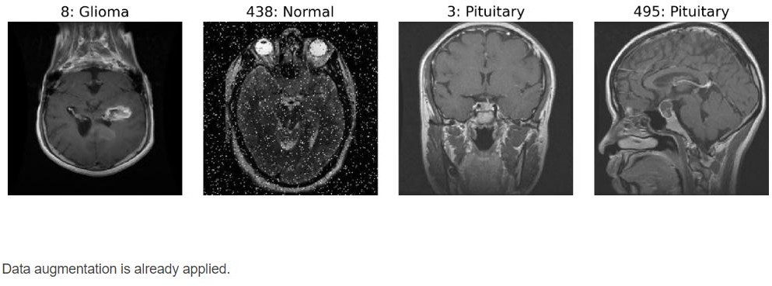

* 1. **Image Shape:-**

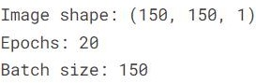

## **CNN model:-**

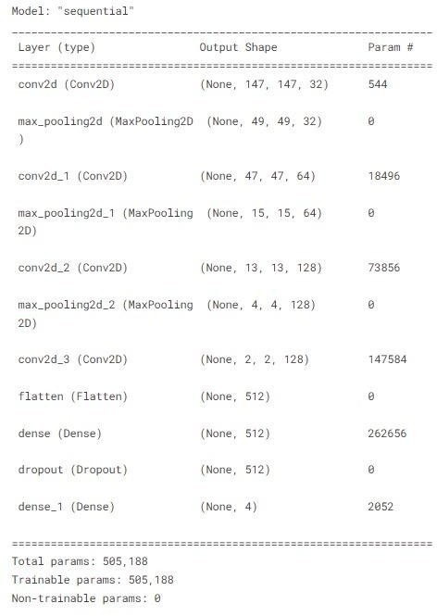

* 1. **Layered View:-**

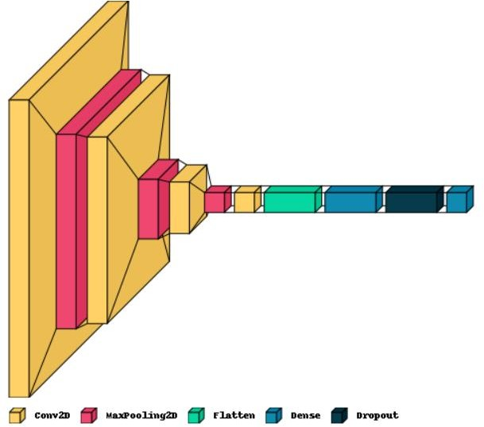

## **Model Accuracy And Loss:-**

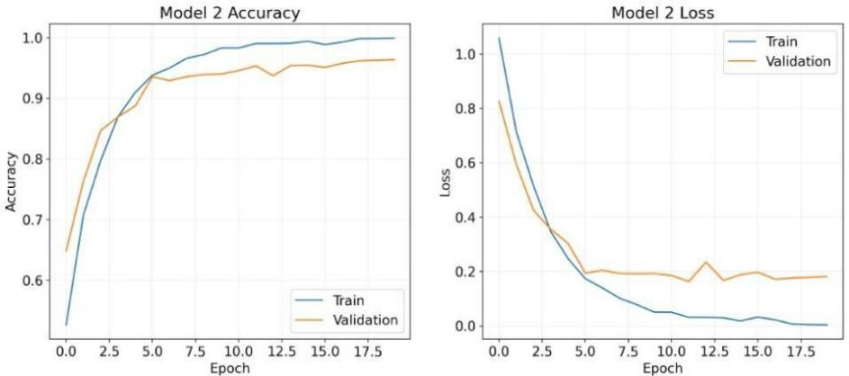

* 1. **Classification report:-**

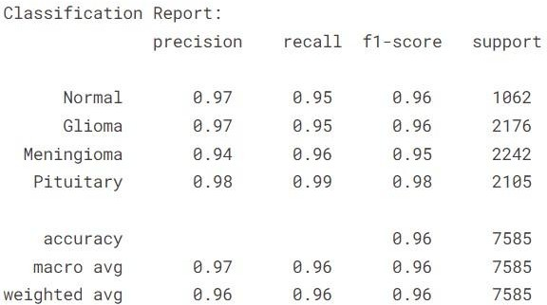

## **Confusion matrix:-**

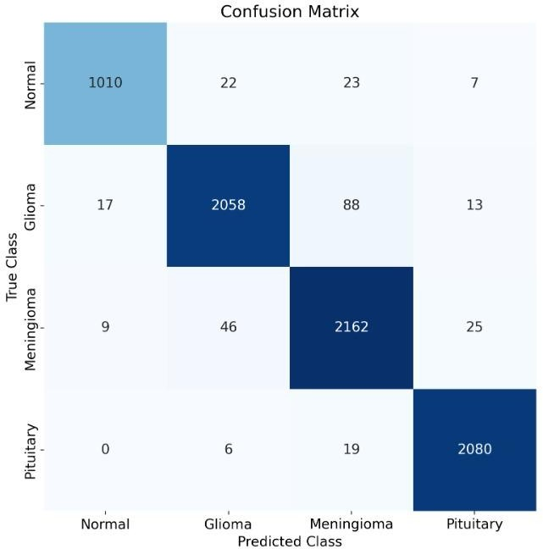

* 1. **Getting image to test output and applying reshaping:-**

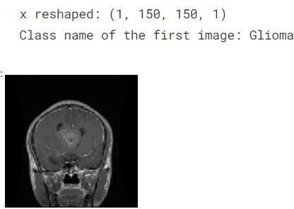

## **CNN Layers:-**

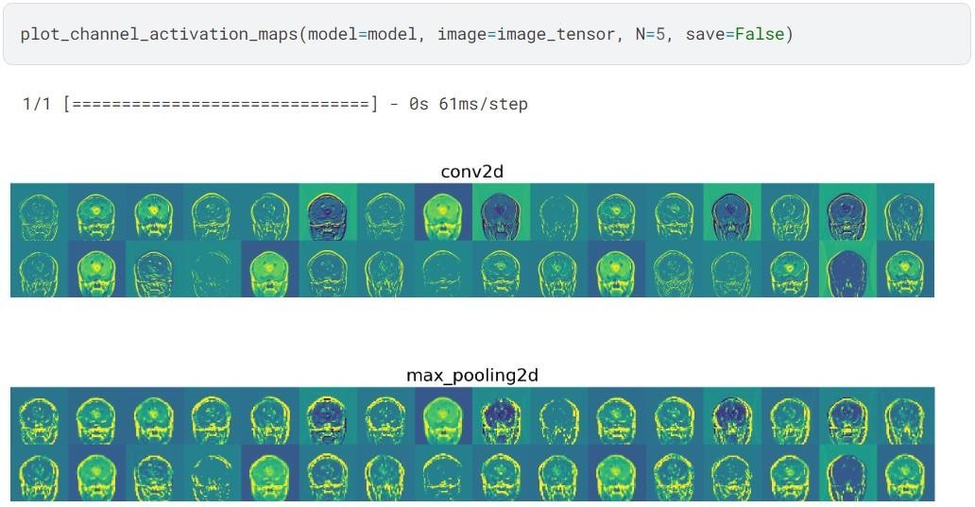

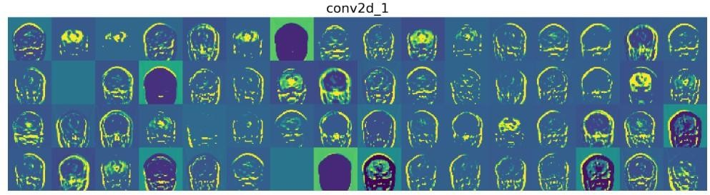

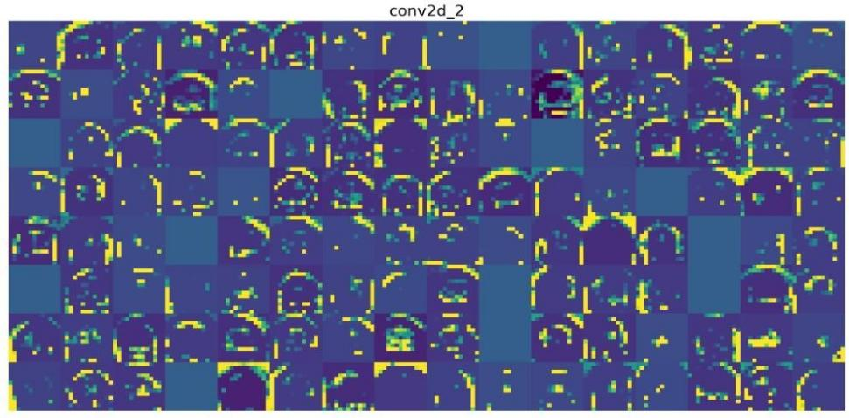

After the model has long gone via the education technique, it is then evaluated the use of a complete set of overall performance metrics:-

* Accuracy: The ratio of the quantity of correct labeled snap shots to the total number of pix.
* Precision: The ratio of genuine positive predictions to the entire tremendous predictions, which shows the ability of the version to keep away from fake positives.
* Recall: This metric, additionally known as sensitivity, calculates the quantity of genuine positive predictions compared to all the actual positives, for this reason the model can become aware of all applicable instances.
* F1-Score: The harmonic suggest of precision and remember that is the single measure and at the identical time balances both issues. One of the model's accompaniments is it registers an amazing 95% accuracy, which denotes the model effectiveness in the discrimination of tumor and non- tumor images. These results are comparable to those in other state-of-the-art models in the literature, showing the competitive performance of the proposed approach.

# **CONCLUSION**

* Its several noted advantages, strength of being easy to apply, productive in terms of results and engages use of picturesque mountain trails in application of deep learning. However, shortcomings also exist, for instance the use of mono data sets, which are not comprehensive for all the brain tumor type.
* Further studies should consider focus on integrated switching learning, whereby conditions are set for the utilization of more precise data sets, hence enhancing overall performance.
* Additionally, imaging modalities need to be enhanced through the addition of more imaging modalities such as CT or PET Finally, strategies aimed at understanding and adoption are very crucial, particularly in the clinical setting where such predictive knowledge The premise can enhance confidence among the physicians and patients.

1. **ACKNOWLEDGEMENT**

We express our humble gratitude to our Honorable Chancellor **DR. T. R. PAARIVENDHAR**, Pro-Chancellor (Administration), **DR. RAVI PACHAMOOTHU**, Pro-Chancellor (Academics) **DR. P. SATHYANARAYANAN**, Pro Chancellor (Admin) for the facilities extended for the completion of the minor project work.

We would like to express our sincere gratitude to our Vice Chancellor, **DR. C. MUTHAMIZHCHELVAN** and Registrar, **DR. S. PONNUSAMY**, for their support in completing our minor project work by giving us the best of academic excellence support system in place. We extend our sincere thanks to our Dean, **DR. C V JAYAKUMAR**, and Vice Principal – Academics, DR. C. GOMATHY and Vice Principal - Examination - **DR. S. KARTHIKEYAN** for their invaluable support.

We wish to thank **DR. S. PRASANNA DEVI**, Professor & Head, Department of CSE, SRM Institute of Science and Technology, Vadapalani Campus for her valuable suggestions and encouragement throughout the period of the minor project work and the course.

We are extremely grateful to our Minor Project Coordinator, **DR. NEELAM SANJEEV KUMAR,** Professor, Department of CSE, SRM Institute of Science and Technology, Vadapalani Campus, for leading and helping us to complete our course.

We extend our gratitude to our supervisor, **MRS.R. DEEPA**, Assistant Professor, Department of CSE, SRM Institute of Science and Technology, Vadapalani Campus for providing us an opportunity to pursue our minor project under his mentorship. He provided us with the freedom and support to explore the research topics of our interest.

We sincerely thank all faculty of DCSE, staff and students of the department who have directly or indirectly helped our minor project. Finally, we would like to thank our parents, our family members and our friends for their unconditional love, constant support, and encouragement.

# **11. REFERENCE**

* Md Ishtyaq Mahmud et al., A Deep Analysis of Brain Tumor Detection from MR Images Using Deep Learning Networks, Published: March 2023, MDPI.
* Md Ishtyaq Mahmud, Brain Tumor Detection Using CNN and MRI Images, Published: June 2023, MDPI.
* Md Abdul Kader, Brain Tumor Detection and Classification using Machine Learning, Published: March 2022, Springer.
* Abhay D. Patil, Brain Tumor Detection Using Deep Learning Models, Published: September 2021, IEEE Xplore.
* Kumar, Explainable AI for Brain Tumor Analysis in MRI Images, Published: August 2023, BMC Medical Imaging.
* Ahmed Abdelgawad, Advances in AI for Brain Tumor Classification, Published: February 2023, Springer.
* F. Chen, AI-Driven Techniques for Brain Tumor Diagnosis, Published: May 2021, IEEE Xplore.
* Muntasir Mamun, Deep Learning Approaches for Brain Tumor Analysis, Published: November 2022, MDPI.
* P. Kumar, AI in Neuro-Oncology: Challenges and Solutions, Published: October 2021, Nature.
* S. Singh, Automated Brain Tumor Segmentation Using AI, Published: July 2022, BMC Medical Informatics.

PUBLICATION CERTIFICATE

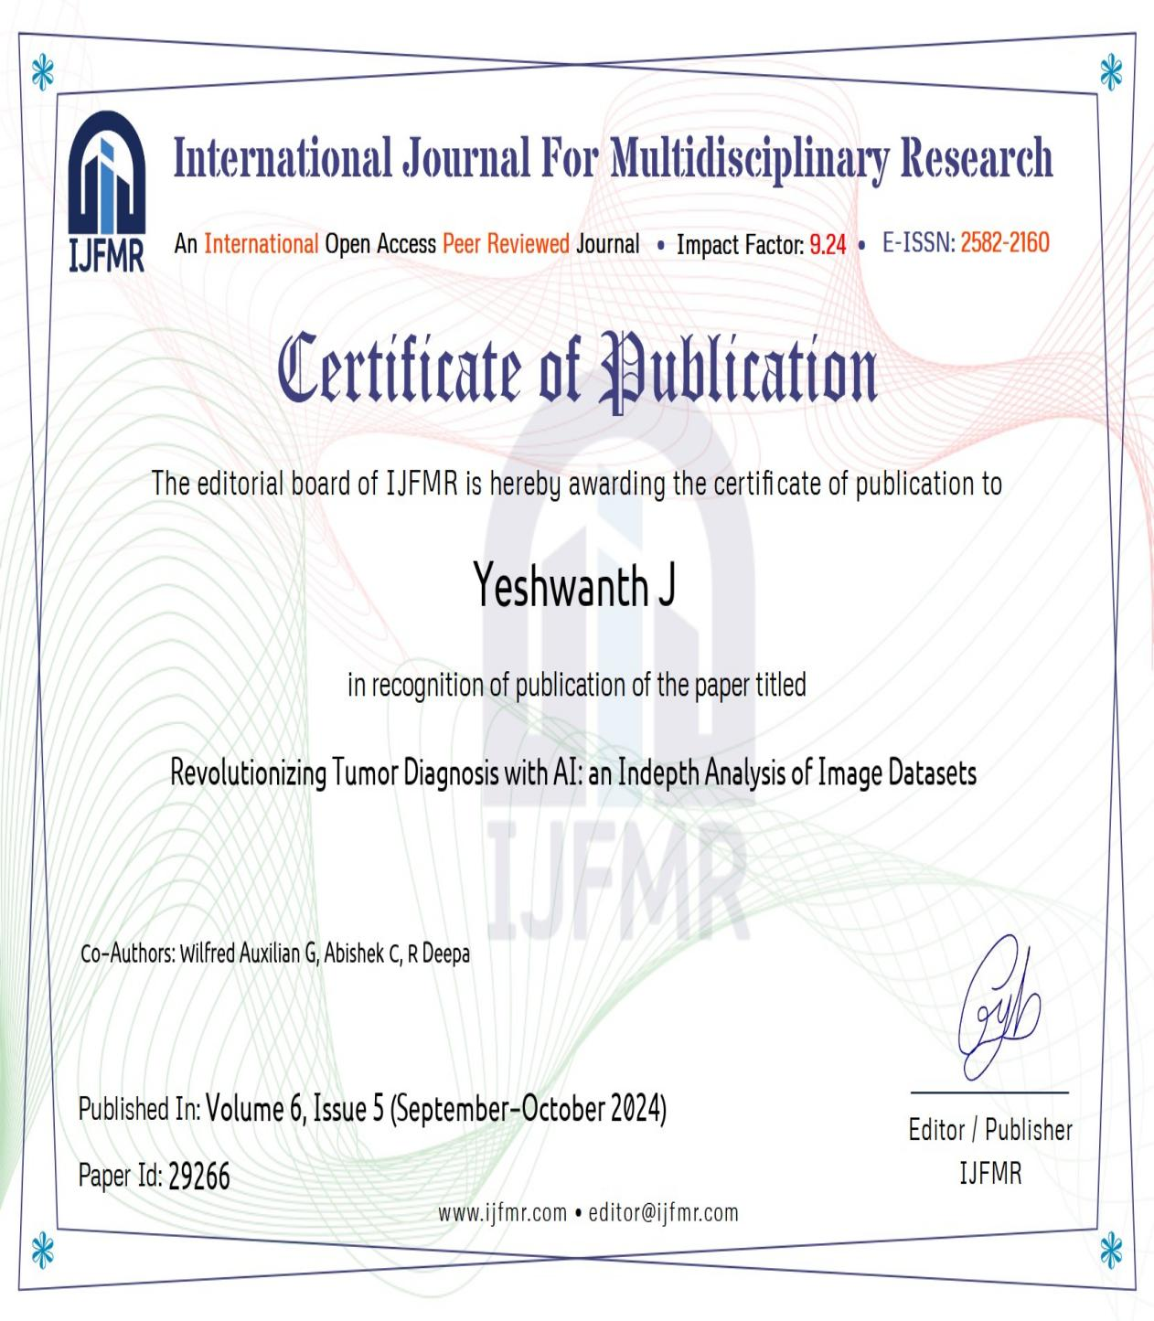

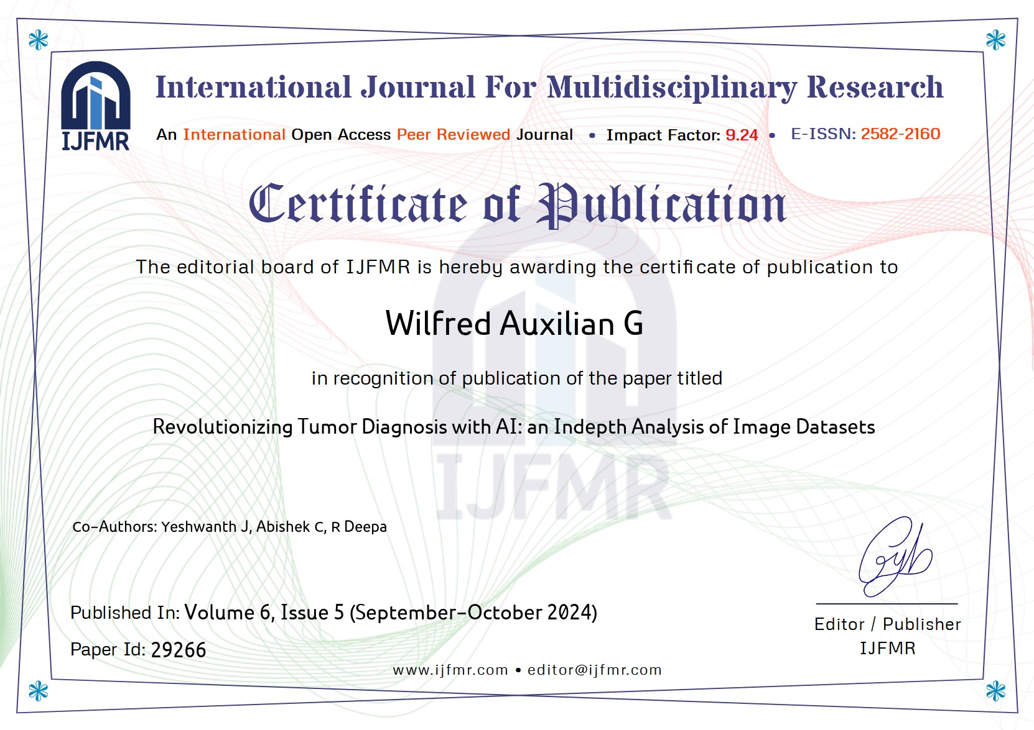

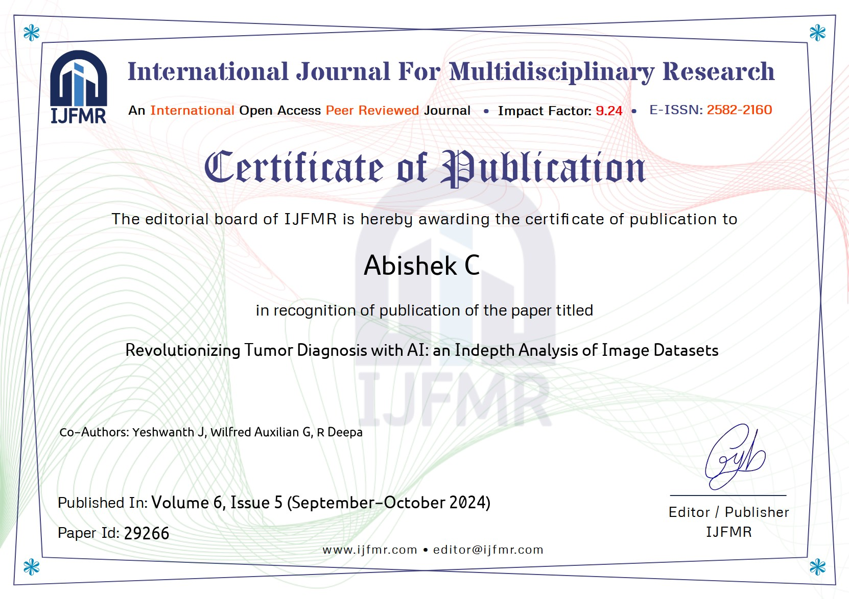

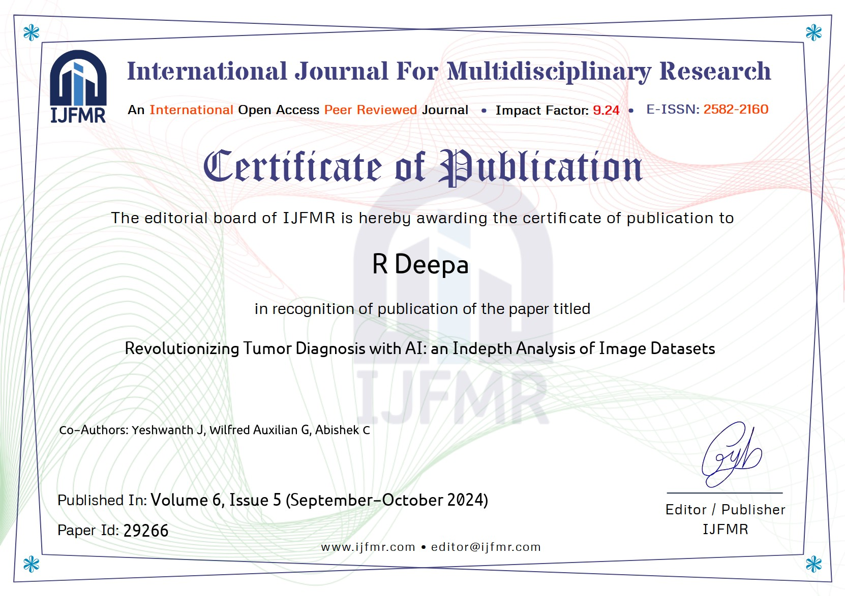

PLAGIARISM REPORT

